April 17, 2014

**FILE MEMORANDUM**

**FROM:** Gary Fredricks, NOAA Fisheries

**SUBJECT:** The Dalles Dam Split Flow Change Request Form

An FPOM subgroup meeting was held on April 10 regarding the issue of splitting flows at The Dalles Dam to relieve crowding in the east ladder. That meeting led me to the following thoughts for the rest of the subgroup to consider:

1. It seems unlikely that a treatment test will work mainly because the crowding conditions will likely not last long enough for a meaningful comparison.
2. Choosing a spill level should be based on gas limits and the urgency of quickly minimizing ladder crowding if it occurs. Using a stepping up process from lower spill levels will likely not provide timely crowding relief.
3. The duration of spill should be based on the need to allow fish time to orient on the spillway early in the day and long enough to keep fish moving to the spillway during the bulk of the daily passage period.
4. The radio tagging study should (assuming we can tag fall Chinook) be geared toward understanding how and when fish approach the project and particularly the spillway and determining passage time though key points in the east ladder. Again, it is unlikely that there will be sufficient time for a treatment test during the high density period of passage.
5. It would be good to get some time with the ERDC 1:80 scale general model in order to develop a spill pattern for this operation. The goal would be to see what spill pattern (and flow) results in attraction flow that extends downstream far enough to be found by adult migrants.
6. It is clear to me that, given the uncertainty surrounding this operation (particularly the adult trigger), that the project fisheries should have some latitude in making changes to the operation based on in-season observations of adults in the ladder.

I have re-drafted my earlier change form as follows with these thoughts in mind.

**DRAFT FPP Change Request Form**

**Change Request Number & Title:** 14TDA009 Split Flows

**Date Submitted:** XXXX - Draft

**Project:** TDA

**Requester Name, Agency:** NOAA Fisheries (and?)

**Location of Change - FPP Project and Section:**

TDA 2.1. Project Operations – General. Add new paragraph 2.1.4.

**Proposed Changes (in track changes to existing section):**

Entirely new section under Section 2.

2.1.4. Project Split Flow Distribution. If adult and jack salmonid counts equal or exceed 25,000 fish per day after August 31, the Project will provide 20 kcfs spill daily for 12 hours between 0400 and 1600 in an attempt to balance adult passage between the east and north fish ladders (TDA-E and TDA-N, respectively). This operation will continue until TDA adult and jack salmon counts fall below 20,000 fish per day. The spill pattern will be modified from the normal spill pattern as indicated in Table XXX. **For 2014, the project fisheries will have the latitude to adjust this operation as necessary to relieve ladder crowding conditions observed in season.**

**Justification for Change:**

The rationale for this change follows the same rationale that lead to the powerhouse flow split at Bonneville Dam (FPP BON Section 2.1.1.1.). Uneven flow distribution at The Dalles Dam, like at Bonneville, can lead to overcrowding in one of the project fish ladders. The situation at The Dalles is unique, however, since the north ladder at this project normally passes a low percentage of the project passage, either due to highly turbulent entrance conditions under normal 40% juvenile spill levels or due to lack of attraction flow during no spill conditions (see Tables 1 and 2). While crowding is less likely at The Dalles Dam than at Bonneville Dam due to significant tributary turnoff in the Bonneville Pool (the TDA Chinook run was about 30% lower than at BON in 2013), there is still the potential for overcrowding the east ladder, particularly when there is a strong run of upriver bright fall Chinook, as seen in the late summer of 2013 (and expected in 2014).

|  |  |  |  |  |  |
| --- | --- | --- | --- | --- | --- |
| Table 1. Spill season (April-August) North Ladder passage percentage for 2010 – 2013. | | | | | |
|  | 2010 | 2011 | 2012 | 2013 | Average |
| Adult Chinook | 31 | 17 | 21 | 28 | 24.3 |
| Jack Chinook | 18 | 6 | 7 | 15 | 11.5 |
| Steelhead | 27 | 10 | 12 | 16 | 16.3 |
| Sockeye | 24 | 3 | 2 | 21 | 12.5 |
| Average | 25 | 9 | 10.5 | 20 | 16.1 |

|  |  |  |  |  |  |
| --- | --- | --- | --- | --- | --- |
| Table 2. Percentage of adult Chinook passage via the North Ladder, September 1- October 31. | | | | | |
|  | 2010 | 2011 | 2012 | 2013 | Average |
| % N. Ladder | 6 | 5 | 7 | 6 | 6 |

A limited spill test in 2013 was conducted at the Dalles Dam in an attempt to encourage higher use of the north ladder. A memorandum summarizing that test is attached. While the test was not conclusive, the pattern of north ladder usage did suggest that a limited amount of spill could encourage additional usage of the north ladder.

Earlier spill tests were conducted by the Corps’ FFU in 1993 and 1994 (Jonas and Stansell, 1995). The 1993 test was conducted with 1,500 cfs spill flow from bay 1. This condition was tested against zero spill. The test was conducted with two day blocks with each condition lasting only one day. The fall 1994 test compared passage counts with a similar two day block design although this time the zero spill day was paired with a 4.5 kcfs spill day. The distribution of passage was monitored at the ladder count stations. While sockeye did appear to respond to the summer 1993 test, neither test significantly improved passage distribution of late summer/fall migrants.

While the 1993 and 1994 tests did not show a significant increase in passage with small amounts of spill, there still are some fish using the north ladder during the no-spill season. Analyzing no-spill passage in September through October in recent years indicates an average of 6% of the adult Chinook project passage occurs via the north ladder (Table 2).

During the normal spill season, when 40% of the river flow is spilled, adult Chinook passage via the north ladder can be substantially higher than it is without spill. Figure 1 indicates the daily north ladder passage percentages for April through October for the past four years (years since the spillwall was completed). These data indicate that Chinook will pass the north side in significant percentages when enough spill is provided. At spill levels as low as 30 to 40 kcfs, the distribution of adult Chinook passing the north ladder is in the 20 to 50 percent range.

Figure 1. Percent North Ladder Passage vs. Daytime Spill Volume. Each data point represents a single day of passage during the four year period. The trend line is a fourth order polynomial line which indicates the central tendency of the data fairly well.

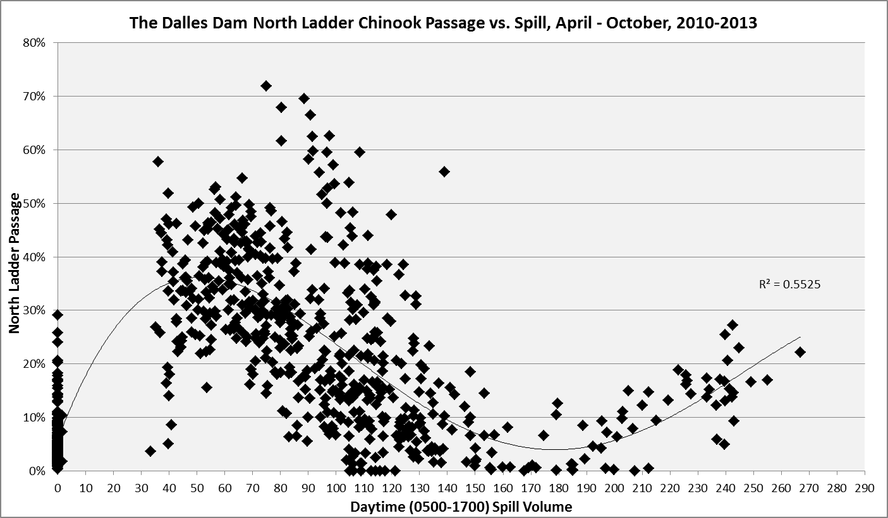

The question of course is what might happen to fish distribution in the zero (or 4.5 kcfs) to 40 kcfs spill range, particularly at the low tailwaters typical during the late summer/fall no-spill period. Will passage increase incrementally as more spill is provided or is there a spill flow threshold after which fish move en mass to the north ladder? The available data examined in this analysis would suggest test spill levels of more than 4.5 kcfs and less than 40 kcfs. We suggest 20 kcfs as a starting point in the proposed FPP language based on the need to effectively move fish immediately once crowding starts to occur. The actual spill volume is based on the Bonneville Dam flow split language where two units of flow (about 20 kcfs) is moved from powerhouse two to powerhouse one. Because of the uncertainty regarding this volume, the project fisheries should have the latitude to adjust this volume as necessary (and with TDG limits) based on ladder observations in-season.

**Operational Trigger**

The question of what fish passage trigger to use was discussed in the April 10, FPOM meeting. Unfortunately, there was no consensus on how to develop this trigger and the records for the development of past triggers apparently do not exist. For now, we recommend using the flow split trigger currently in use at Bonneville Dam, until something better is developed. The post-spill season trigger to begin split operations is 25,000 adult (and jack) salmon passing the project and the trigger to end split operations is 20,000. This is likely a low trigger for The Dalles given that the capacity of the ladder system at this project is less than that of Bonneville Dam, particularly given the low usage of the north ladder. Because of this uncertainly, the project fisheries should have the latitude to adjust the use of the flow split operation as necessary in-season based on their observations of crowding conditions in the east ladder.

**Timing and Duration of the Operation**

Figure 2 illustrates the passage pattern of all adult (plus jack) salmon at The Dalles Dam from mid-August to mid-October of 2013. Total passage exceeded the proposed 25,000 fish trigger on September 8 and dropped below the 20,000 fish trigger on September 22 (with a one day drop below 20k on September 16), for a total period of 14 days. Larger or smaller runs will surely effect this period, however, the passage pattern in 2013 gives some idea of what the duration of this operation might look like.

Figure 2. TDA late summer adult passage, all salmon species.

The daily timing and duration of spill is also an issue that deserves more consideration. We chose a twelve hour spill period starting at 0400. Starting spill this early should give fish a chance to key in on the north ladder as they start to pass the project. However, this assumes fish are in the vicinity of the spillway and north shore and have the “opportunity to discover” the attraction spill. The duration of spill was simply chosen to provide attraction over the bulk of the daylight primary adult passage hours. Further investigation of the available radio tag data may help refine these values.

**Spill Pattern**

Another question is what spill pattern should be used for the attraction spill. The spill table provided in the current FPP is based on best downstream passage for juvenile migrants, not upstream passage for adults. A pattern that starts at bay seven (as the current pattern does for 20k spill) may not be appropriate for adult attraction. Also, gate openings should be sufficiently open as to provide a distinct flow signature downstream of the spillway without blocking fish access to the north ladder entrances. The current four foot minimum opening should be sufficient, however, this should be examined more closely with adult attraction in mind. Years ago, some work was done on an adult spill pattern with the current wall configuration. These investigations should be revisited with this late summer/fall adult passage issue in mind.

Ultimately, it may be necessary to investigate new patterns with the ERDC general model of this project. We might be able to use the actual project (prototype) to accomplish this, however, this has a couple of problems. First, it is important but very difficult to see what flows are doing under the surface, particularly in a flow environment as complex as the tailrace of The Dalles project. Second, it is unlikely that anyone would agree to stop juvenile spill during the spill season for this test and there may be no time for this after the end of August and before the onset of peak passage.

**Dissolved Gas**

Dissolved gas generation will need to be monitored during this operation. The Oregon waiver ends at the end of the spill season (August 31) so dissolved gas generated by this spill will need to be at or below 110% at the TDA downstream gauge. The data in Figure 3 summarize the TDG levels at this gauge generated by the spill levels that occurred in August since spillwall was installed. The year 2011 was omitted because spill and TDG levels were well above what we are considering for the entire month. The data suggest that the 110% TDG level likely occurs at about 25 to 30 kcfs spill. Spreading the spill out a bit from the normal pattern might help reduce TDG levels further.

**Figure 3. TDG vs. August spill volumes.**

**Research**

Given the short duration of the operation (~ 2 weeks) it is unlikely that any block design type of study could be done. Count distribution between the ladders can be compared to past years to see if the operation was having the desired effect. In addition, this is a year when a large radio tracking study is planned for the lower Columbia River. This study, as originally planned, did not include fall Chinook. Because of this, the region will need to consider if moving tags from another stock is appropriate. The researchers have indicated that, because of tag size issues, the most likely stock to pull from the current study would be steelhead, either the early group or the late (overwintering) group. Each group equals about 400 tags. The pros and cons of this species swap should be discussed soon by the Study Review Work Group. Besides the usual suite of data collected in these studies, it would be useful to examine approach distribution (north vs. south) below The Dalles project, the timing associated with approach behavior at the north entrance and passage time in specific ladder pools (particularly turning, count window and exit pools) in the east ladder.

Attachment 1.

**FILE MEMORANDUM** November 7, 2013

**FROM:** Gary Fredricks

**SUBJECT:** A Review of the 2013, The Dalles Dam Attraction Spill “Test”

On September 14 through 16, the Action Agencies agreed to try a limited amount of daytime spill to help reduce adult fish crowding in the East Ladder at The Dalles Dam. Flow in the amount of three kcfs was spilled for seven hours (0600 – 1200) from the north spillbay with the idea of pulling more fish to the North Ladder. The action was stopped after three days because the agencies deemed the action ineffective. While the effort was ineffective in relieving the East Ladder crowding, I believe the following data fail to support any assessment that the effort was not effective in moving fish.



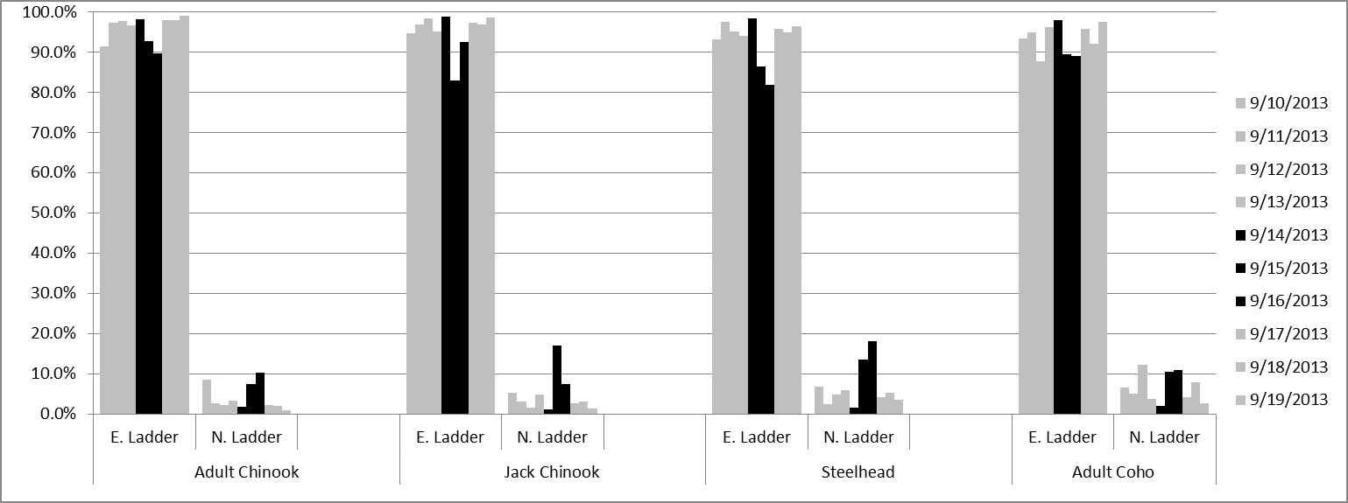

I believe the data clearly show what appears to be a response in ladder passage at the North Ladder as a result of the additional spill. The spill amount was quite small compared to the total river flow and the duration of the additional attraction spill was short and started when the fish would normally have already started entering the ladder systems. Even so, it appears that after a day lag time, several species of salmon did respond to the additional spill. This test is was certainly too short and too limited to provide any conclusive information. However, these results do indicate that any claims of failure may be unfounded and they also leave the question of whether a more determined effort would have been successful in reducing the east ladder crowding situation. A comparison of these data with the radio tracking data collected this year may shed additional light on this issue.